**Bug_Id: LG-1011**

**Title:** Password is Displaying Unmasked

**Description**:  
The password field is displaying the entered password in plaintext, rather than masking it with asterisks (or similar characters).

**Prerequisite:**

* Do Not click on the Show password option
* Valid username and password

**Severity:** High

**Steps to Reproduce:**

1. Launch the URL in web browser
2. Enter the username and password
3. Observe that the password is displayed in plain text (unmasked) instead of asterisks or dots.

**Expected Result**:

The password should be masked as the user types it to protect privacy.

**Actual Result**:  
The password is displayed as plain text, which is a security risk.

**Screenshot:**

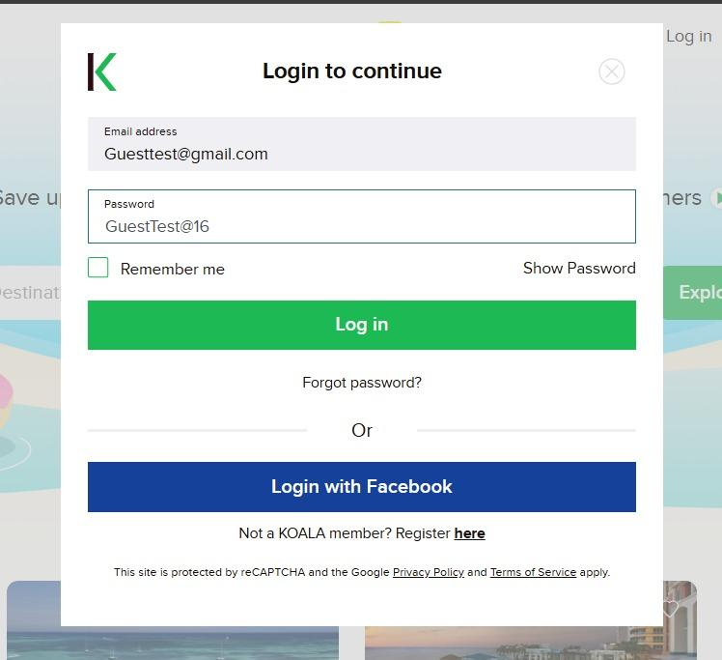

**Bug_Id: LG-1012**

**Title**: User Not Logged Out After Inactivity Period

**Description**:

The user is not automatically logged out after a specified inactivity period, leading to potential security risks where the session remains active indefinitely even if the user is not interacting with the application.

**Prerequisite:**

* Valid username and password

**Severity:** High

**Steps to Reproduce**:

1. Log in to the application.
2. Remain inactive for a specific time period (e.g., 15 minutes).
3. Observe that the user is still logged in and can interact with the application, despite the inactivity timeout.

**Expected Result**:

After an inactivity period, the user should be automatically logged out, and any subsequent action should redirect the user to the login screen or prompt them to log in again.

**Actual Result**:  
The user remains logged in after the session timeout, allowing interaction with the app even when the session has expired.

**Screenshot:**

